RODALS SRL
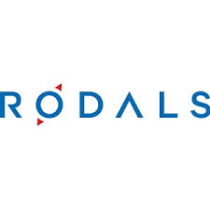
https://rodals.md/

CONACUL CONTESEI SRL

https://www.facebook.com/LaContessa2018/?locale=ro_RO
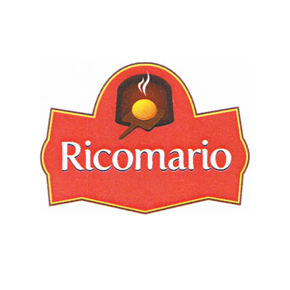
RICOMARIO SRL

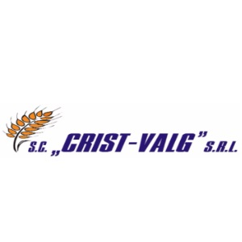
CRIST - VALG SRL

PRODUSE CU TRADITIE SRL

https://www.facebook.com/CuTraditii/

HEGEMON GRUP SRL

https://www.brutaria-cuptoras.md/

IUGINTERTRANS S.A.

https://milina.md/ro/

SAVIT-SIM SRL
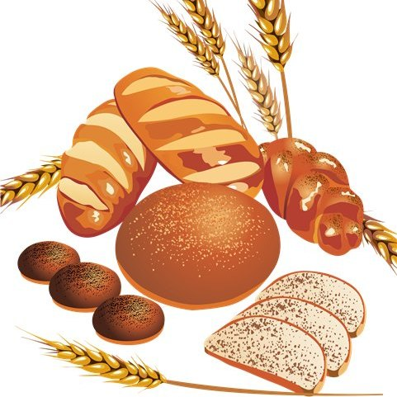
https://www.facebook.com/savitsim1996

MĂCINĂTORUL SRL
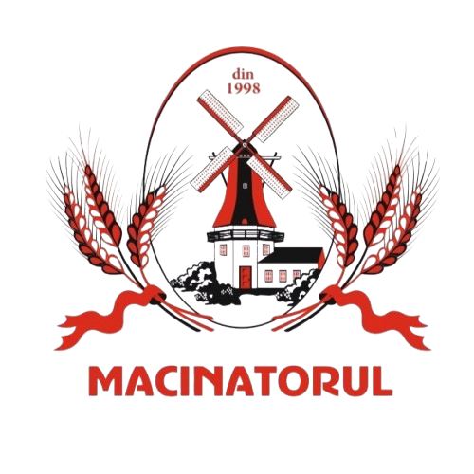
https://macinatorul.com/

ECO-GRAIN ELEVATOR SRL

https://www.facebook.com/ecograinelevator

BUDNEA RODICA Î.I.

https://www.facebook.com/profile.php?id=100088436980271

BRODEȚCHI SRL

https://www.facebook.com/Brodetchi

”GLINCOR - COM” S.R.L.

https://brutariaglincor.md/

Cahul Pan SRL

https://cahulpan.com/

Oleineac SRL


https://oleineac.md/

Aceștea de mai jos nu au nici logoo nici fb nici site respectiv puneți-le denumirile cu un Shirift mai deosebit.
AGROCERPROD SRL
PRICOP IGOR OLEG GȚ
FRANDALEX-AGRO SRL
SOLGON - I SRL
IUNALIS-AGRO SRL
RICONDUCT SRL
Generalchim SRL

